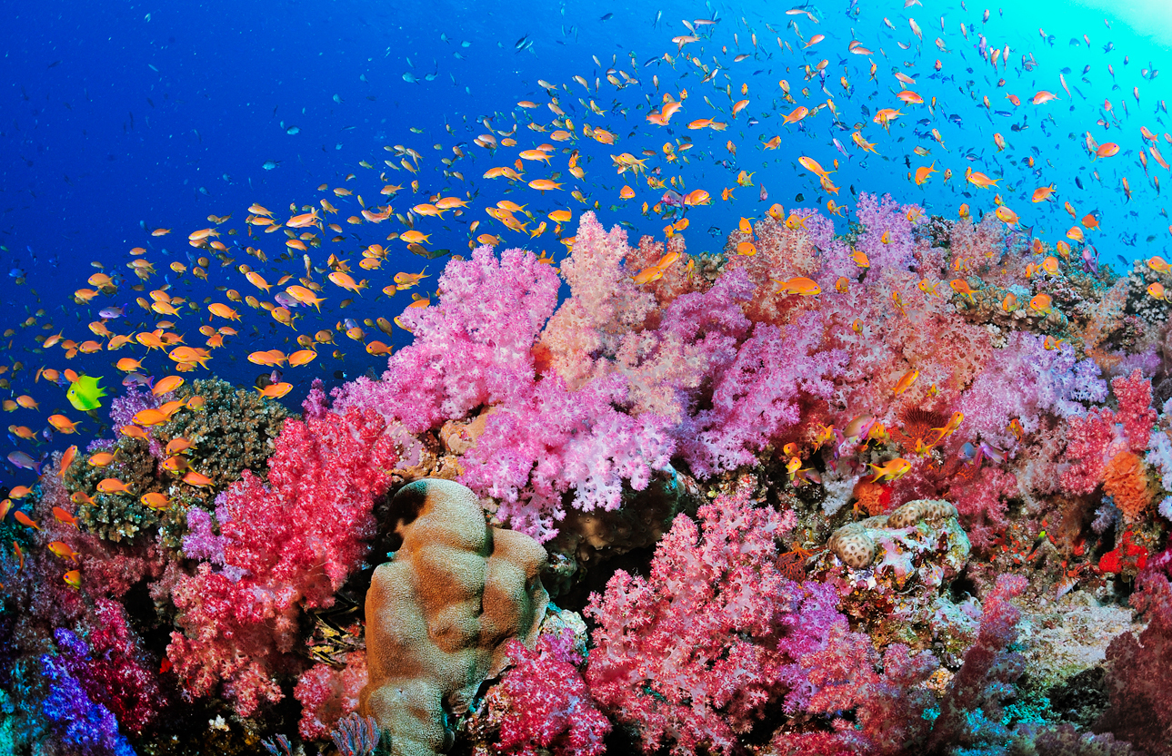

ES2001 MATLAB Project Individual Report

**Coding Corals**

# Chia Chong Rong Reynold

# U1640743L

# 10th November 2017

**1. Introduction**

1.1 Background

The main aim of our group’s project is to investigate the correlation between climate change and coral resilience in the North Pacific Ocean. A total of 7 parameters related to climate change were investigated. They are Sea Surface Temperature (SST), Sea Surface Temperature Anomaly (SSTA), Ocean Heat Content (OHC), total Carbon Dioxide (CO2) concentration in the sea, Degree Heating Weeks (DHWs), mean seawater pH and bleaching hotspots. These parameters were investigated together with parameters which estimate coral survivability, such as bleaching severity code, bleaching occurrence probability, coral population, and coral distribution.

The group’s hypothesis is that climate change has a direct impact on coral population, however, different species of corals may exhibit varying degree of resilience. To add further depth into this research, the different species of coral and their variation in numbers were also analysed to determine if there was variability in the resilience based on the different species.

1.2 Scientific Question

How resilient are deep sea coral populations in the face of climate change?

**2. Regional Setting and Time Frame**

The region our group chose to work on is the North Pacific Ocean. There are a few reasons why our group decided to use this regional setting. Firstly, we wanted to investigate the hypothesis that reef formation in the North Pacific was difficult due to global climate change and ocean acidification (Amy, et al., 2017). We also chose this region because of the many National Marine Sanctuaries and Marine Protected Areas (MPAs) present in the North Pacific (MPAtlas, 2017) which were effective in enhancing coral survivability in the face of climate change in the region. This would help to limit the influence of anthropogenic factors such as overfishing and tourism on the coral reefs.

**3. Reason for choosing the timeframe 2000-2015**

Global Climate Models show that the thermal thresholds of corals will be exceeded more often as Climate Change worsens, causing bleaching events to occur more frequently (IPCC, 2007) Thus, our group decided to focus on more recent years. This would also allow us to have a more in-depth analysis based on this timeframe. Another reason why we chose to look at this time frame is that data sets in more recent years are more reliable due to modern technology and recording devices.

**4. Data Sets**

The following data sets are those which I have analysed or assisted in analysing.

|  |  |  |  |  |
| --- | --- | --- | --- | --- |
| Data | Description | Deliverables | Format | Source |
| Bleaching Severity Code | Severity code is classified as such: -1 being unknown, 0 being No Bleaching, 1 being mild, 2 being moderate and 3 being severe bleaching. | • Map showing areas with recorded severity code over time. | Excel Spreadsheet File (.xls) | Observational Bleaching Database. |
| Bleaching Occurrence Probability | In this data set, the probability of bleaching occurrence between 1985 and 2010 was modelled across the world’s warm water coral reefs at 0.04° X 0.04° latitude-longitude resolution using indicator kriging. Probabilities were not estimated for years in which there were too few or no reports. | • Map showing probability of bleaching occurrence globally | Tagged Image File Format (.tif) | Interpolated Bleaching Probability Database |
| SST, SSTA, DHW, Hotspots | Different parameters of climate change recorded at various stations located in the North Pacific Ocean | • Graph of SST, SSTA, mean of all datasets against time.  • Plot of SST, SSTA, DHW, Hotspots over time on a map | Text file (.txt) | NOAA Coral Reef Watch Virtual Stations |
| Thermal Stress Level, SST max, SST anomaly min, max, mean, hotspot max and DHW max. | Annual Composites  of Twice-Weekly 50-km Satellite Coral Bleaching Monitoring Products | • Plot of thermal stress level (Figure 5) SST (Figure 6), SSTA (Figure 7), Hotspot (Figure 8) and DHW (Figure 9) data on a world map over time. | Hierarchical data format (.hdf) | NOAA Satellite and Information Service |
| Normalised Dissolved Inorganic Carbon (nDIC) and pH of seawater | Data was collected at a site that represents the North Pacific subtropical gyre and contains mean seawater salinity nDIC data, which represents total CO2 concentration, and mean seawater pH. | • Graph of nDIC and pH over time | Text file (.txt) | Hawaii Ocean Time-series (HOT) program |

**5. Role in Project**

My role in this project is to attempt to extract and plot severity code data in the observational bleaching database, as well as to plot interpolated bleaching probability data from the interpolated bleaching probability database created by Simon D. Donner and his research team (Simon, et al., 2017) for further analysis. Another role of mine is to plot climate change indicators on a map obtained from NOAA Coral Reef Watch Virtual Stations for each year. I also played a part in helping other group members load CO2 and pH data into MATLAB, and in coding animations for figures.

**6. MATLAB techniques**

Observational Bleaching DataBase

|  |  |
| --- | --- |
| Problem encountered | Solution |
| File format is in .xls format. | I used **xlsread** to read xls file into MATLAB. By default, MATLAB has to read data into xlsread into 3 outputs, num, txt and raw to read numeric, text and raw data separately. To increase efficiency of code, I used tilde (~) marks to replace outputs num and txt when using xlsread, to only read the raw data which can be processed easier. |
| Defining longitude for the North Pacific region when using an if loop to extract out indexes from the raw data. | The data given is of global scale, however, I just want to focus on the North Pacific Region. The North Pacific region spans across the anti-meridian line from 129 ° E to - 100°E. However, if I were to find the indexes of data if the longitude of data is more than 129° and less than -100°, it wouldn’t make sense to MATLAB as these are conflicting statements.  Therefore, I split the **for** loops into 2, and found all indexes using function **find** for indexes when longitude is between 129° to 180°, and another loop for indexes when longitude is between -180° to -100°. The indexes are all concatenated into the same blank vector created before the beginning of both for loops. The resulting map region is shown in figure. |

Interpolated Bleaching Probability Data Base

|  |  |
| --- | --- |
| Problem encountered | Solution |
| File format is in .tif format | Used **geotiffread** to read geotiff file into MATLAB. Outputs are a georeferenced grayscale image A and a spatial reference object R. |
| A has many large negative values (-1.70 x 10^­308). | Used **min** and **max** functions to get a sense of range of data as manually scrolling and looking through the whole 3120x8640 matrix is too tedious. Input for min and max function was A(:). Colons in brackets was used to convert matrix A to a single column vector as **min** and **max** can only give a single smallest and largest value if vectors are input. If **min** and **max** functions were used directly on matrix A, output will be a row vector containing the maximum value of each column, which is not what I want.  Used **hist** function to create a histogram to observe for any skewing of data, which might mean corrupt values. It turns out that there were excessive values of -1.70 x10308. It is assumed that these values mean corrupt or missing data, as the data represents probability, which cannot be negative. Converted all these values to NaN by using the following code: A(A(:)<0) = NaN . |
| Values were not displayed on a map | Used **pcolor** to create a pseudo-color map to show probability of bleaching around the world. Used **shading flat** to remove outlines around colored portions so that the outlines do not overwhelm and cover the raw data. |

NOAA Coral Reef Watch Virtual Stations

|  |  |
| --- | --- |
| Problem encountered | Solution |
| Data for each station in North Pacific are all in separate .txt files. | Used function **dir** and specified **\*.txt** in concatenated file name to get a structure containing all .txt files in the same folder. Used function **extractfield** and specified ‘name’ to extract only the names of the .txt files as cell format. Converted the cell format to string format by using function **char.**  The respective file names are then concatenated with full directory path defined above in the code in a for loop, to look through all the .txt files and used function **textread** to read the data in each .txt file. |
| When creating map, map region is not zoomed into North Pacific region. | When using function **axesm,** property ‘origin’ is specified at latitude 0°, longitude 180° and 0° angle of rotation about the axis running through the origin point and the center of the earth. This is so that the world map is oriented and centred at the North Pacific region. Properties ‘MapLatLimit’ and ‘MapLonLimit’ is used to zoom into North Pacific for a clearer view of the stations. |
| Default colorbar colors are not distinct enough. | Used **colormap jet** to set colorbar to have a larger range of colors to see more distinct change in parameters. |
| Scatter plots are all in different figures and not animated. | Created only one figure, and under one for loop, used **getframe** to get a frame of each loop, then **frame2im** and **rgb2ind** to finally get an indexed image, which is used to create a gif file for animation. Function **imwrite** is used to write each frame into a gif file. |

NOAA 50-km Satellite Coral Bleaching Monitoring Products

|  |  |
| --- | --- |
| Problem encountered | Solution |
| Data file is in .hdf format | Used function **hdfread** to read hdf file into MATLAB and output an array of int16 values. Specified data set in input to read specific parameter. |
| World map showing bleaching alert area shows only 2 colours, brown and blue. (Figure) There is no sensible observation to analyse. | Bleaching thermal stress levels in alert areas are only classified from 0 to 4, 0 being No Stress and 4 being Bleaching Alert 2. This information is obtained by looking at the dataset’s “variable_info” field in the information structure obtained by using the function **hdfinfo** on the hdf file.  Used **min, max** and **hist** to get a sense of values in image. Realised that there are many values above 4, which does not make sense in this context. Converted all these extra values to NaN by using the following code: max_alertarea (max_alertarea>4)= NaN, where max_alertarea is the structure obtained upon reading hdf file.  Used **imagesc** to display image with scaled colors after removing NaN values. |
| Scatter plots are all in different figures and not animated. | Created only one figure, and under one for loop, used **getframe** to get a frame of each loop, then **frame2im** and **rgb2ind** to finally get an indexed image, which is used to create a gif file for animation. Function **imwrite** is used to write each frame into a gif file. |

Loading nDIC and pH data into MATLAB

|  |  |
| --- | --- |
| Problem encountered | Solution |
| Dates in .txt file are in format dd-mmm-yy. Eg. “01-Jan-01” (Figure 1) | Dates in .txt file are read into MATLAB as cells using **textread**. Function **find** cannot be used for elements in cell format. Thefore, I firstly used **cell2mat** to convert dates in cell format to character format in a single matrix. Used **datenum** to convert dates into days since 00 Jan 0000, then used **datevec** to create a numeric array which values represent dates and time in years, months, days, hours, minutes, and seconds. The **find** function can then be used to find the specific years which our group is interested in. |

**7. Discussion**

Limitations of data sets

For the observational bleaching database, the severity code records were not consistent during the period of interest. For example, from 2001 to 2003, the locations and number of records of severity codes differed every year (Figure 9, Figure 10, Figure 11). After plotting the data, our group agreed that this data set will be unreliable for our analysis, and thus excluded this from our project.

For the interpolated bleaching probability data base, after attempting to plot the data onto a map, the data does not seem to be reliable as there are records of bleaching occurrences even on land. There may have been a problem defining the axes of the map according to the image, however, more details about this dataset could not be found. Therefore, our group also agreed that this data set will be unreliable for further analysis and thus excluded this data set as well.

For NOAA 50-km Satellite Coral Bleaching Monitoring Products, the data is in 50km resolution, which might not give a very accurate representation of climate change indicators over time. A smaller resolution of 5km could be used, however the data has not been released fully yet (National Oceanic and Atmospheric Administration, 2017).

**8. Conclusion**

Since severity code and bleaching occurrence probability was not included in the final analysis due to unreliable data, the resilience of corals was analysed based on coral population and coral distribution. Based on the group’s defined climate change indicators, we conclude coral populations have generally decreased throughout the years from 2000 to 2015, from which there was drastic reduction in coral population in years 2010 and 2014. Worsening climate change conditions does lead to a decrease in coral population. However, there are varying levels of resilience between different species of corals. Soft corals, demosponges, black corals and sponges are the types of deep sea coral which are the least resilient to climate change. On the other hand, other types of coral such as the glass sponges and gorgonian sponges showed increasing resilience to climate change as they adapted to the worsening climatic conditions. Among all the coral species analysed, the group found that sea pens could be the most resilient species as their population increased during both bleaching events.

Appendix A: Figures

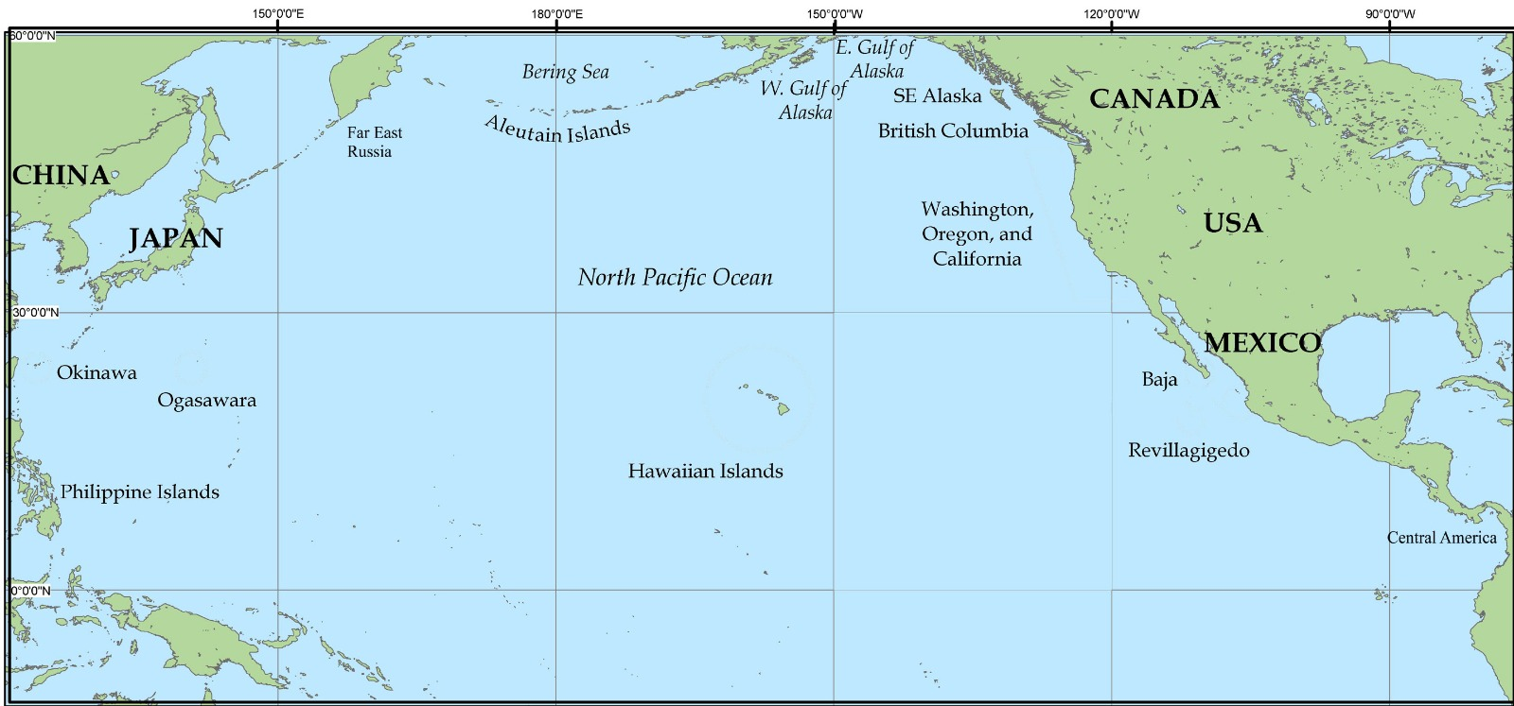

Figure 1. Map of North Pacific Ocean

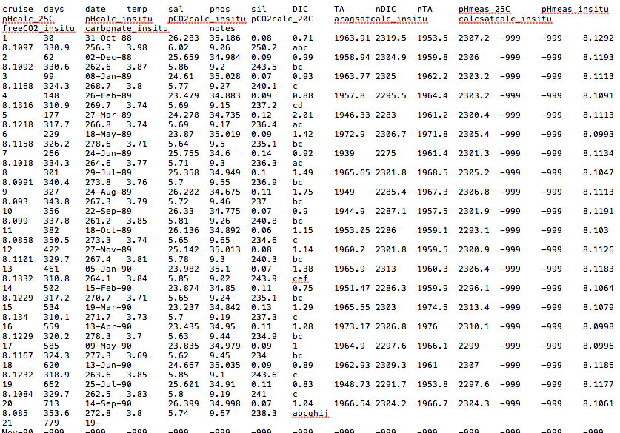

Figure 2. Raw data of CO2 and pH data obtained from the Hawaii Ocean Time-Series (HOT) program



Figure 3. Code showing how CO2 and Ph data was read into MATLAB.

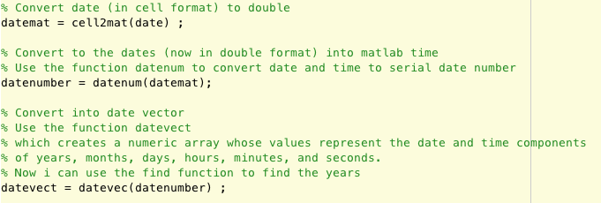’

Figure 4. Code showing how date data in text file was converted for function find to be used to extract data for relevant years.

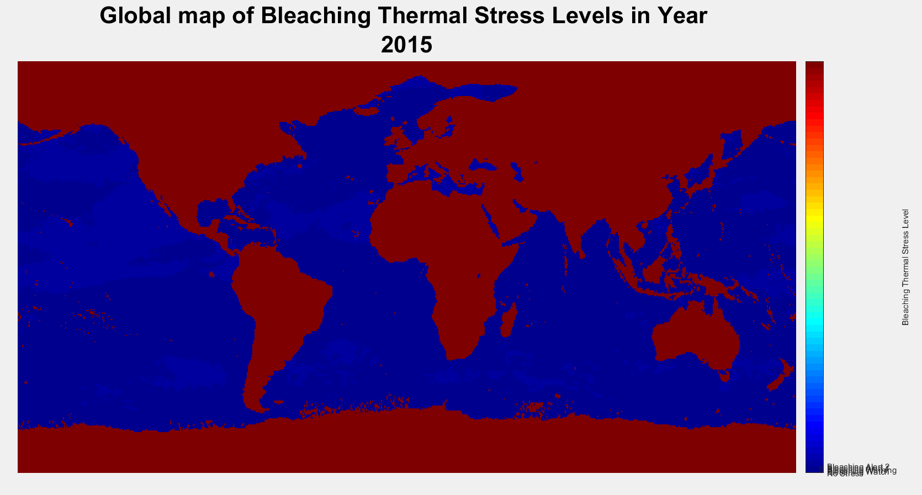

Figure 5. World map of bleaching thermal stress levels including corrupt values.

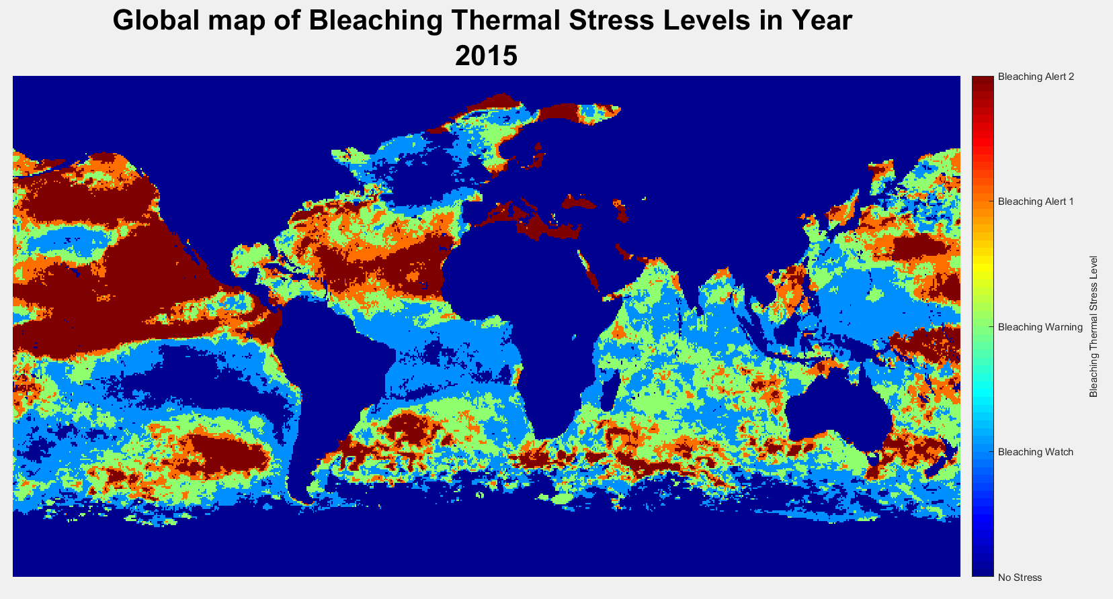

Figure 6. World map of bleaching thermal stress levels excluding corrupt values.

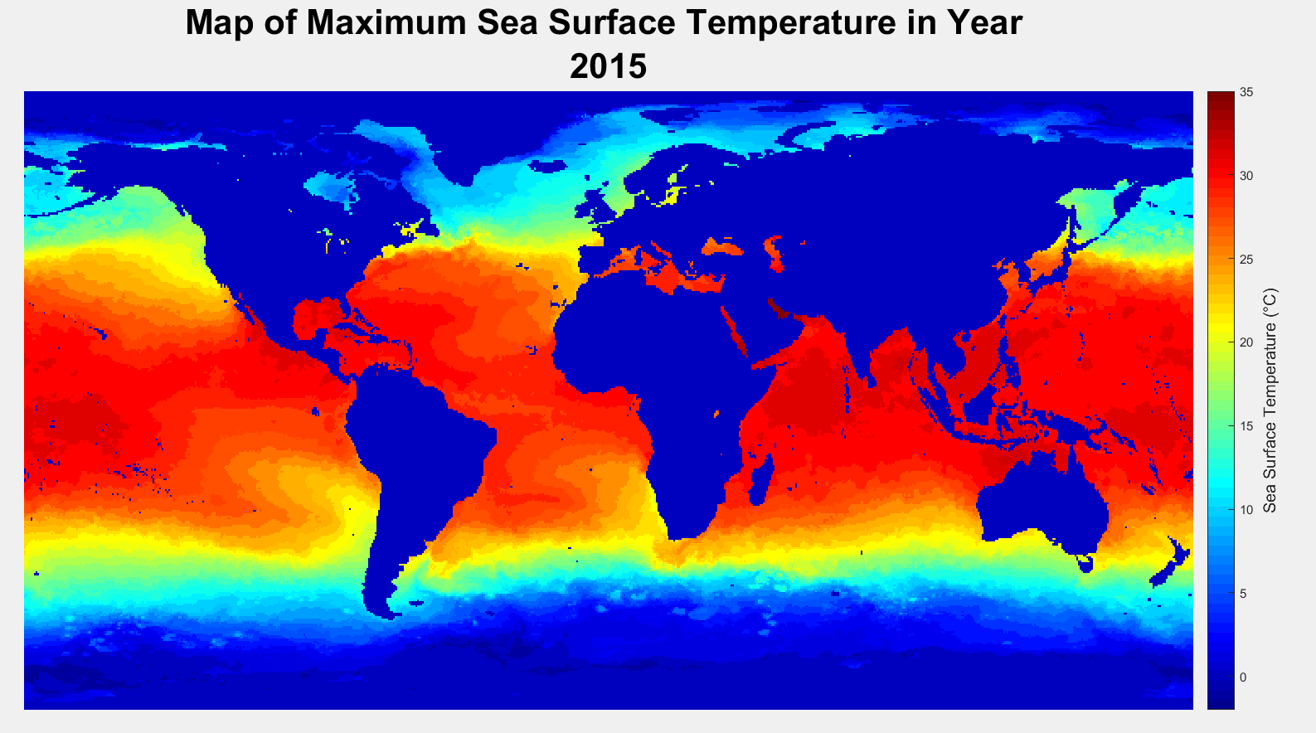

Figure 7. Global map of maximum Sea Surface Temperature in Year 2015

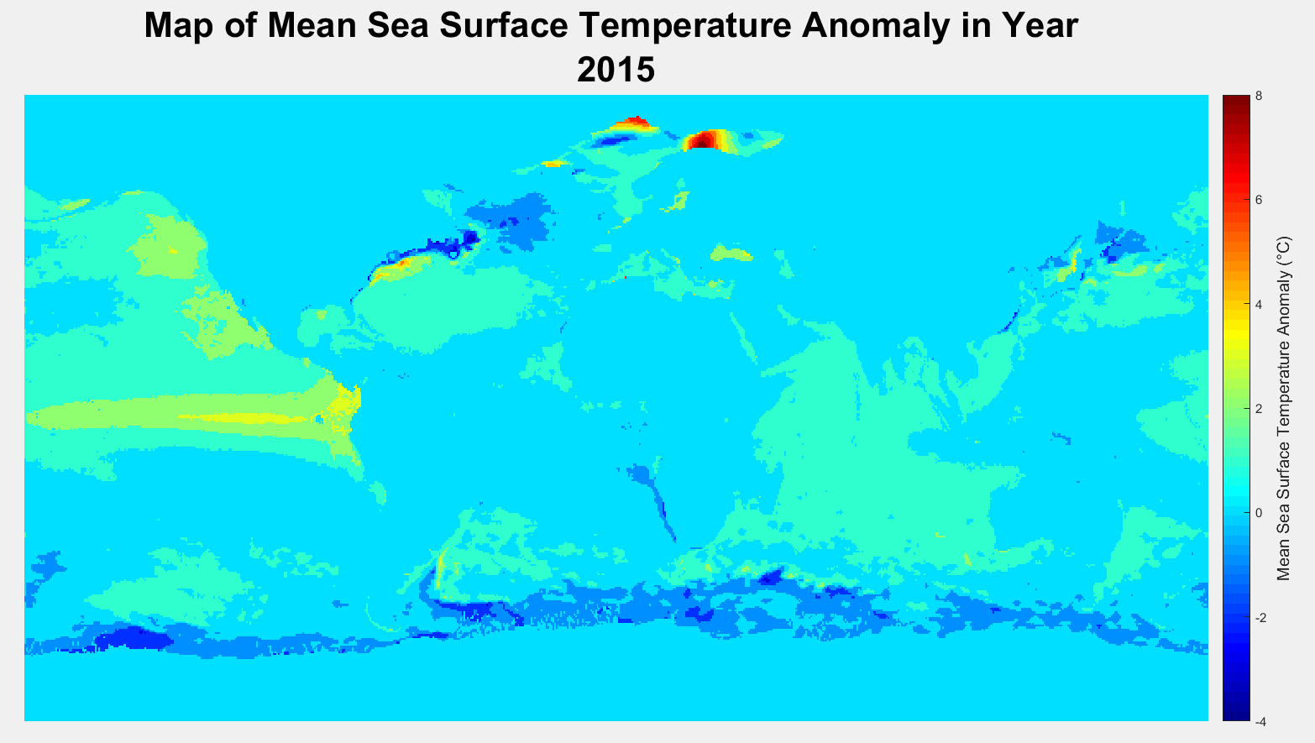

Figure 8. Global map of maximum Sea Surface Temperature Anomaly in Year 2015

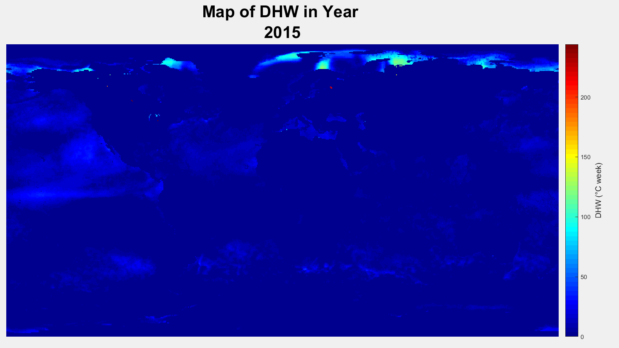

Figure 9. Global map of maximum Degree Heating Weeks in Year 2015

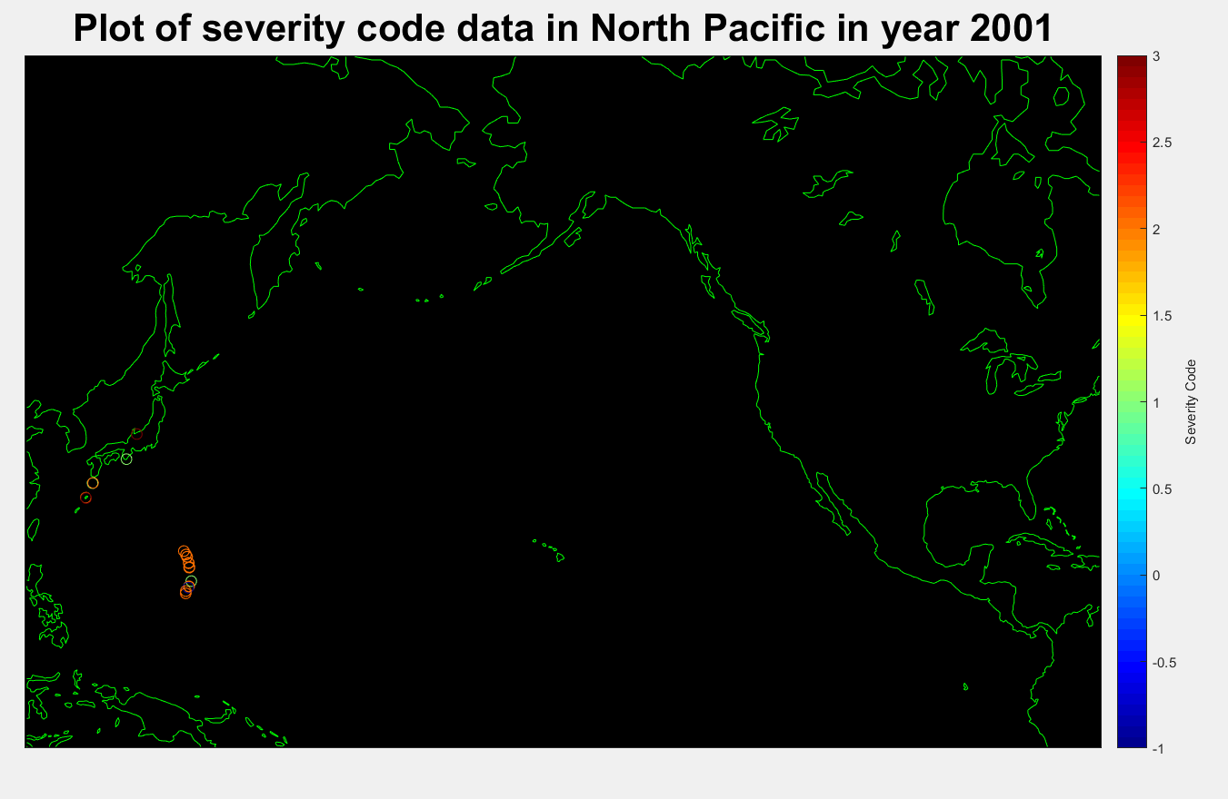

Figure 10. Global map of severity code in year 2001

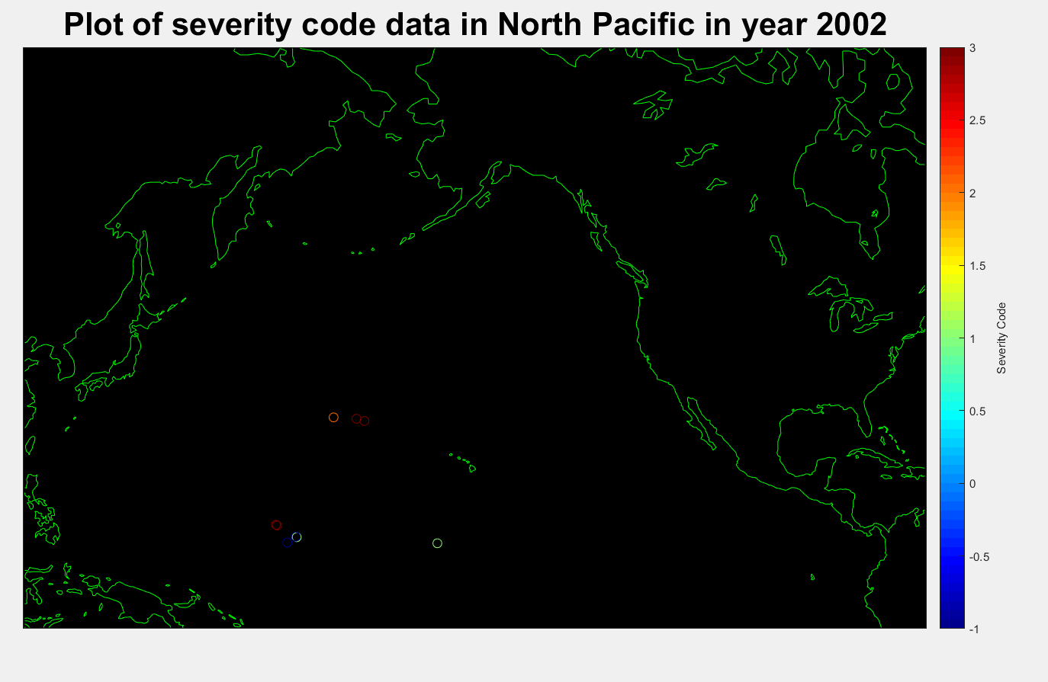

Figure 11. Global map of severity code in year 2002.

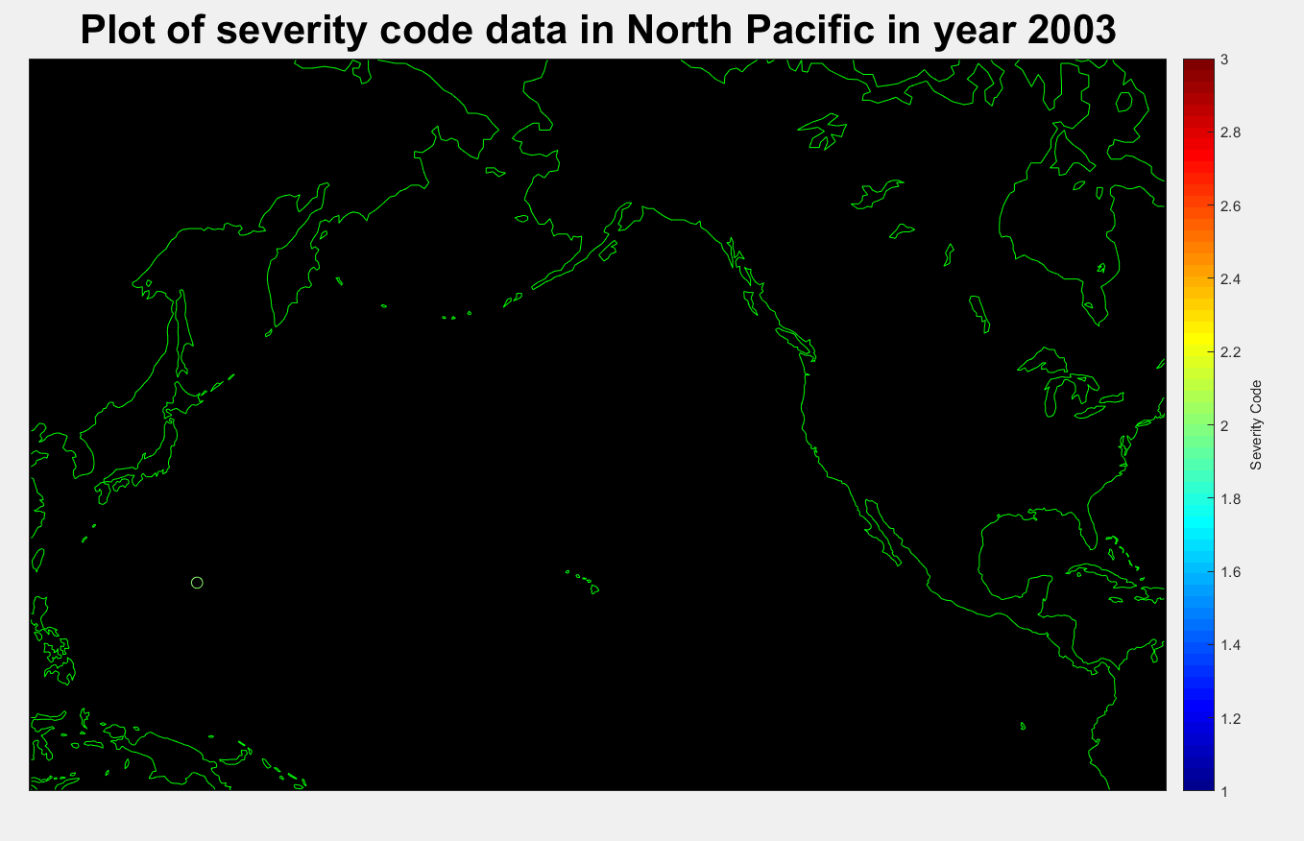

Figure 12. Global map of severity code in year 2003.

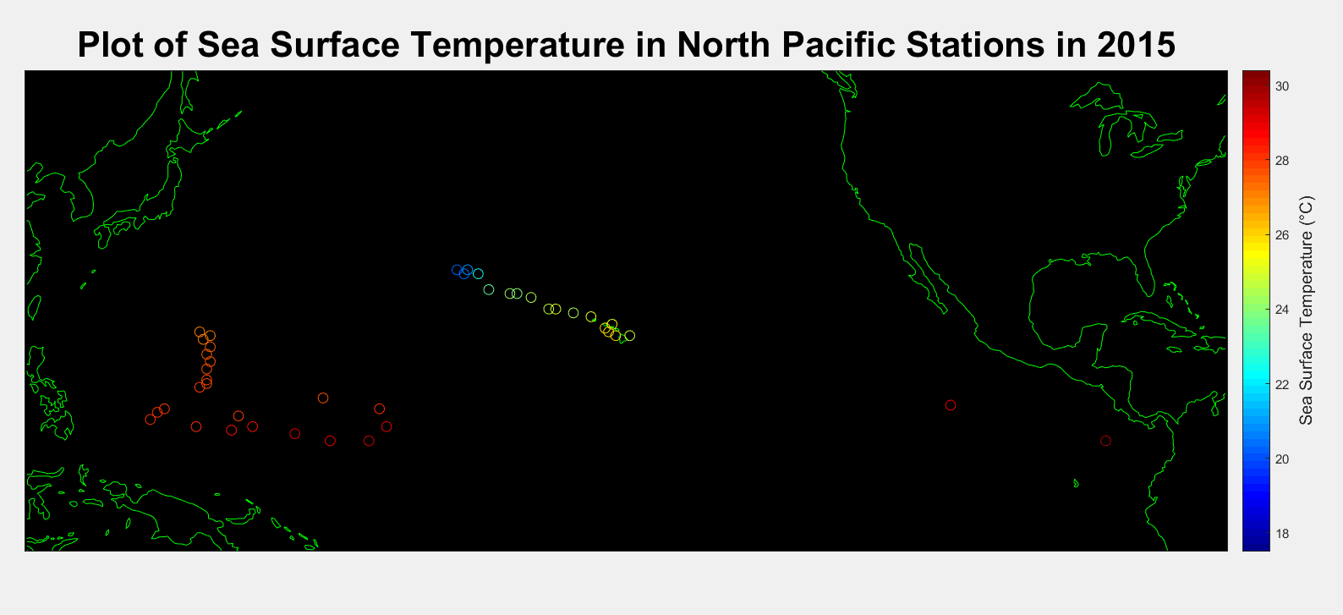

Figure 13. Plot of Sea Surface Temperature in the North Pacific in 2015. This is one of the frames used in the .gif file made to animate the change in Sea Surface Temperature over time. In the .gif file made, the locations of stations remain the same, but the colors change based on the recorded sea surface temperature.

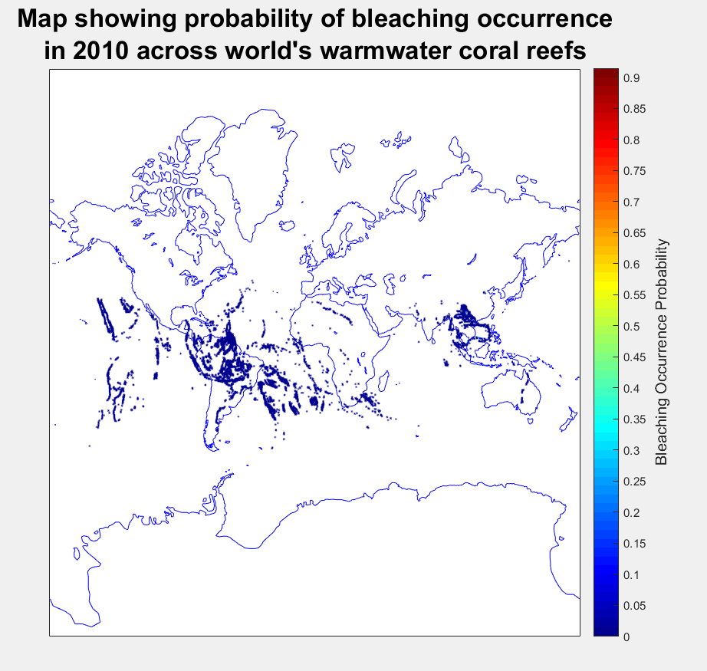

Figure 14. Map of bleaching probability occurrence. Data does not seem reliable due to presence of data on land. More details of data is needed.

**Appendix B: Peer Contributions**

|  |  |
| --- | --- |
| Nicholas | 1. Sourcing data for ocean heat content 2. Obtaining yearly coral population data 3. Find the years where there is decrease in coral records 4. Calculating yearly sea surface temperature, sea surface temperature anomaly, dissolved inorganic carbon and pH levels 5. Plotting the above datasets, along with DHW and hotspot data into figures and analyzing them 6. Creating functions to read the coral and bleaching dataset (with help from Reynold and Ze Ming) 7. Final analysis of project |
| Skye | 1. Sourcing & downloading North Pacific deep-sea coral distribution data 2. Calculating and plotting individual coral species records across time 3. Plotting yearly coral distribution by color 4. Plotting histograms of coral species by year 5. Animated the figures in 3 & 4 6. Created a function and creating ***for*** loops to make ‘Climate change indicator script’ more efficient 7. Plotting linear best-fit line for OHC 8. Assisted in organising data to plot SST, SST anomaly, DHW Hotspot data in North Pacific Region on a map. 9. Final analysis of project |
| Kai Ting | 1. Obtaining yearly coral population data 2. Calculating the correlation between coral records and yearly sea surface temperature (SST), SST anomaly, dissolved inorganic carbon (nDIC), pH levels 3. Plotting the above datasets into figures and analyzing them 4. Analysing the Coral Records graph and extracting out the years where bleaching occurred 5. Final analysis |
| Ze Ming | 1. Sourcing for DHW, SST, SST anomaly, Hotspot data in North Pacific region 2. Source for CO2 and pH data in North Pacific Region 3. Calculating and plotting individual coral species records across time 4. Data conversion and extraction for coral species distribution 5. Calculating yearly DHW and hotspot data 6. Plotting histogram to show annual coral distribution among different species 7. Final analysis |
| Reynold | 1. Analysing degree of bleaching in North Pacific by plotting stations with recorded bleaching severity code on a map. 2. Analysing interpolated probability of bleaching occurrence between 1985 to 2010. 3. Helped Ze Ming plot SST, SST anomaly, DHW, Hotspot data on a map obtained from NOAA Coral Reef Watch Virtual Stations for each year. 4. Assisted in reading the dissolved inorganic carbon and pH levels data into MATLAB 5. Assisted in loading data of coral distribution into MATLAB. 6. Analyzing the final figures and drawing conclusions. 7. Assisted in creating animation for yearly coral distribution and histograms 8. Final analysis |

**Appendix C: References**

# References

Amy, R. B. et al., 2017. Defying Dissolution: Discovery of Deep-Sea Scleractinian Coral Reefs in the North Pacific. *Scientific Reports,* 7(5436), pp. 1-11.

IPCC, 2007. *IPCC: Climate Change 2007: Impacts, Adaptation and Vulnerability.,* Cambridge, UK: Cambridge University Press.

MPAtlas, 2017. *MPAtlas.* [Online]   
Available at: http://mpatlas.org/  
[Accessed November 2017].

National Oceanic and Atmospheric Administration, 2011. *NOAA Coral Reef Watch Virtual Stations.* [Online]   
Available at: https://coralreefwatch.noaa.gov/satellite/vs/docs/list_vs_group_latlon_201103.php  
[Accessed November 2017].

National Oceanic and Atmospheric Administration, 2017. *NOAA Satellite and Information Service: Coral Reef Watch.* [Online]   
Available at: https://coralreefwatch.noaa.gov/satellite/bleaching5km/index.php  
[Accessed November 2017].

Paul, L. J. & Eric, K. B., 2004. Global warming, regional trends and inshore environmental conditions influence coral bleaching in Hawaii. *Global Change Biology,* Volume 10, pp. 1627-1641.

Simon, D. D., Gregory, J. M. R. & Scott, F. H., 2017. A new, high-resolution global mass coral bleaching database. *PloS one,* pp. 1-17.